**Lab 6**

**Discrete Fourier Transform**

**EECS3451**

**Name: Chethana Wickramasinghe**

**Student Number: 214866511**

**Professor: Peter Lian**

**8th of April 2021**

**1. Introduction:**

Using MATLAB to answer questions provided. Questions leads to verifying the properties of DFT, using the convolution to calculate the output of the LTI DT system, and using DFT and IDFT to find the output of an LTI DT system. This report is mainly answering the provided questions using MATLAB. Results will demonstrate the use of MATLAB properly in analysing applications using Discrete Fourier Transform.

**2. Equipment:** MATLAB

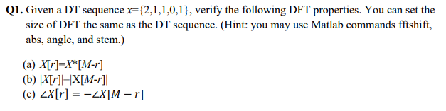**3. Results and discussion:**

N=5; k = 0:N-1;

xk= [2 1 1 0 1];

**a)**

% X(r)

Xr = fft(xk);

w = -pi:2*pi/N:pi-2*pi/N;

subplot(2,1,1),stem(w, Xr);

xlabel('r');

ylabel('X[r]');

title('X[r]');

% X*[M-r] conjucate of complex x+yj -> x-yj and vise versa

cXr = conj(Xr);

subplot(2,1,2),stem(w, cXr);

xlabel('r');

ylabel('X*[M-r]');

title('X*[M-r]');

**%they are the same**

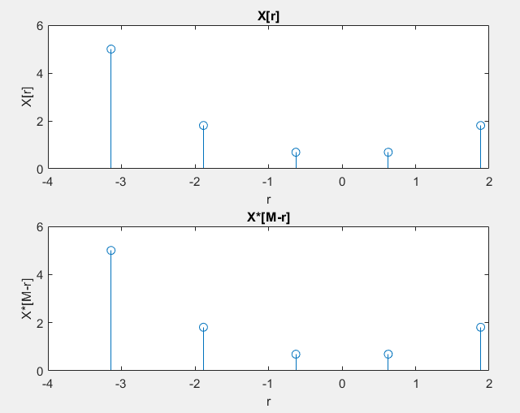

%Shifted for better observation purpose

Xr = fftshift(fft(xk));

w = -pi:2*pi/N:pi-2*pi/N;

subplot(2,1,1),stem(w, Xr);

xlabel('r');

ylabel('X[r]');

title('X[r]');

% X*[M-r] conjucate of complex x+yj -> x-yj and vise versa

cXr = conj(Xr);

subplot(2,1,2),stem(w, cXr);

xlabel('r');

ylabel('X*[M-r]');

title('X*[M-r]');

%they are the same

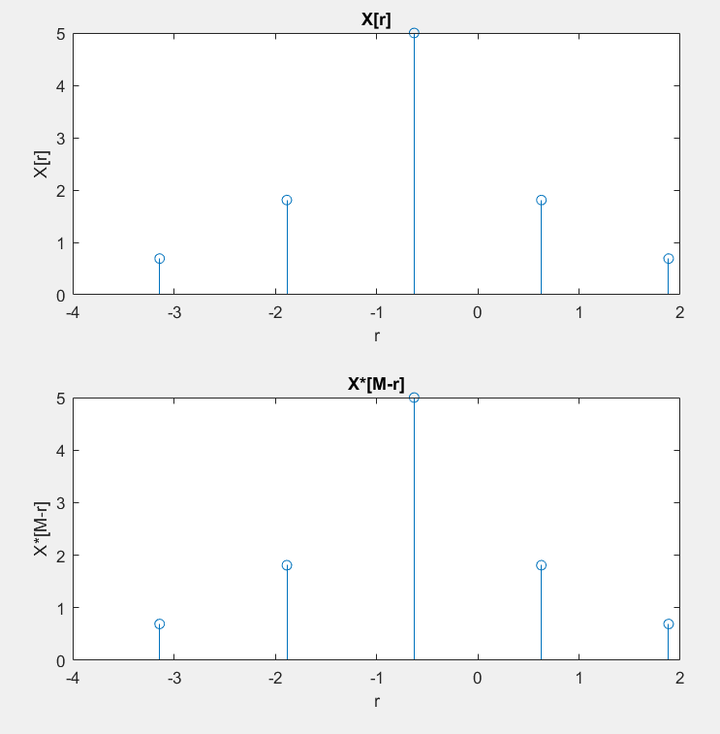

**b)**

subplot(2,1,1),stem(w, abs(Xr));

xlabel('r');

ylabel('|X[r]|');

title('|X[r]|');

subplot(2,1,2),stem(w, abs(cXr));

xlabel('r');

ylabel('|X[M-r]|');

title('|X[M-r]|');

**%they are the same**

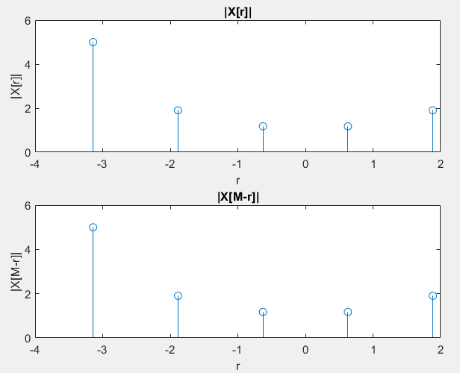

**c)**

subplot(2,1,1),stem(w, angle(Xr));

xlabel('r');

ylabel('<X[r]');

title('<X[r]');

subplot(2,1,2),stem(w, -angle(cXr));

xlabel('r');

ylabel('-<X[M-r]');

title('-<X[M-r]');

**%they are the same**

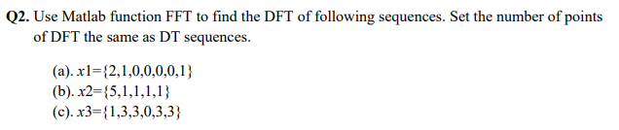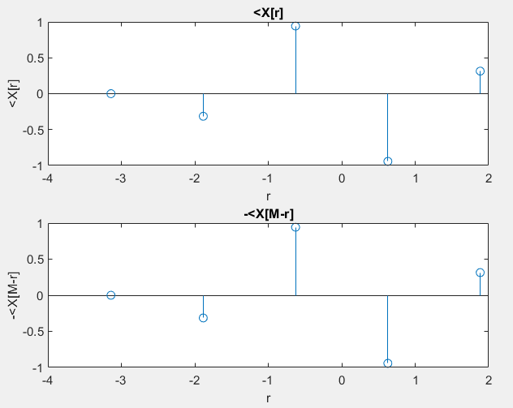

**i) What is your observation on DFTs of x1, x2, and x3?**

N1=7; k1=0:N1-1;

x1k = [2 1 0 0 0 0 1];

X1r = fft(x1k);

X1r = fftshift(X1r);

w1 = -pi:2*pi/N1:pi-2*pi/N1;

subplot(3,1,1),stem(w1, X1r);

xlabel('r');

ylabel('X1[r]');

title('X1[r]');

N2=5; k2=0:N2-1;

x2k = [5 1 1 1 1];

X2r = fft(x2k);

X2r = fftshift(X2r);

w2 = -pi:2*pi/N2:pi-2*pi/N2;

subplot(3,1,2),stem(w2, X2r);

xlabel('r');

ylabel('X2[r]');

title('X2[r]');

N3=6; k3=0:N3-1;

x3k = [1 3 3 0 3 3];

X3r = fft(x3k);

X3r = fftshift(X3r);

w3 = -pi:2*pi/N3:pi-2*pi/N3;

subplot(3,1,3),stem(w3, X3r);

xlabel('r');

ylabel('X3[r]');

title('X3[r]');

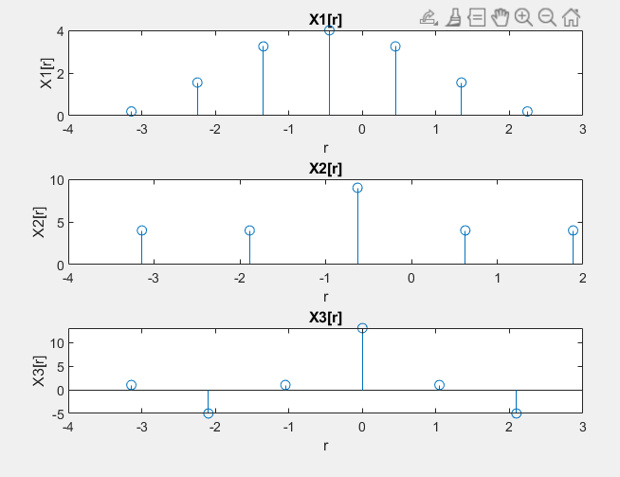

Observation are as shown in the plots above. They have different number of points. X[3] has negative values.

**ii) Change the number of points of DFT to 16, what is your observation on the DFTs of**

**x1, x2, and x3? Explain your observations.**

N1=7; k1=0:N1-1;

x1k = [2 1 0 0 0 0 1];

X1r = fft(x1k, 16);

X1r = fftshift(X1r);

w1 = -pi:2*pi/N1:pi-2*pi/N1;

subplot(3,1,1),stem(X1r);

xlabel('r');

ylabel('X1[r]');

title('X1[r]');

N2=5; k2=0:N2-1;

x2k = [5 1 1 1 1];

X2r = fft(x2k,16);

X2r = fftshift(X2r);

w2 = -pi:2*pi/N2:pi-2*pi/N2;

subplot(3,1,2),stem(X2r);

xlabel('r');

ylabel('X2[r]');

title('X2[r]');

N3=6; k3=0:N3-1;

x3k = [1 3 3 0 3 3];

X3r = fft(x3k,16);

X3r = fftshift(X3r);

w3 = -pi:2*pi/N3:pi-2*pi/N3;

subplot(3,1,3),stem(X3r);

xlabel('r');

ylabel('X3[r]');

title('X3[r]');

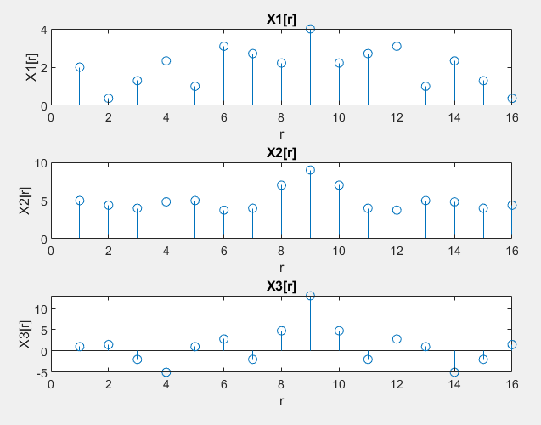

Observations are as shown in the plots above, more intermediate frequency values compared to DFT with same points as sequence. They all have 16 points because we extended the points of DFT to 16, but not the same length as the sequence in previous part of the question.

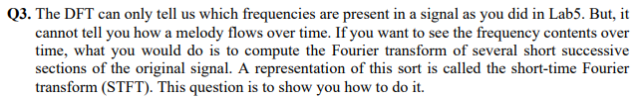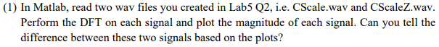

[cy1,fs1]=audioread('CScale.wav');

[cy2,fs2]=audioread('CScaleZ.wav');

subplot(2,1,1),plot(abs(fftshift(fft(cy1))));

xlabel('t');

ylabel('fft');

title('DFT of Cscale');

subplot(2,1,2),plot(abs(fftshift(fft(cy2))));

xlabel('t');

ylabel('fft');

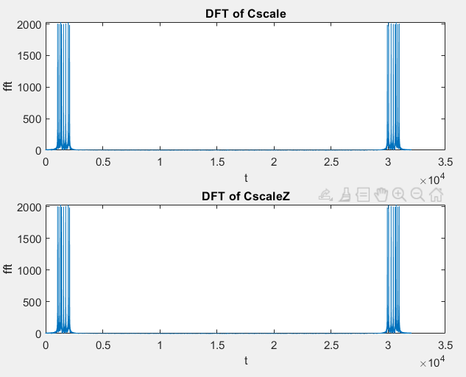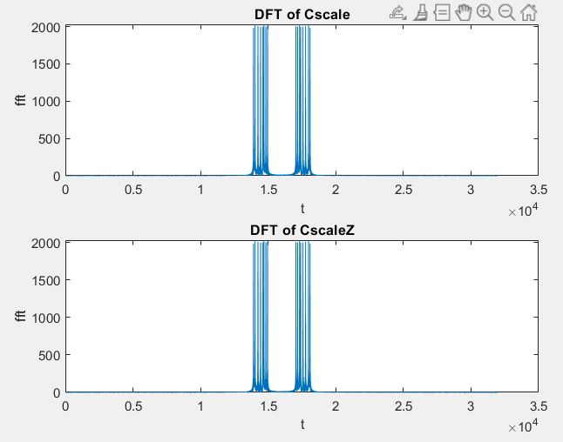title('DFT of CscaleZ');

Non Shifted Shifted

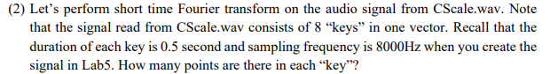**There isn’t an visible difference between DFT of Scale and DFT of CscaleZ.**

4000 points because Sampling frequency was 8000 samples/seconds and each key has a duration of 0.5 seconds.

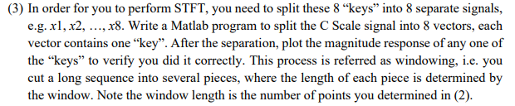8000/2 = 4000 points

Window length = 4000

x1 = cy1(1:4000);

x2 = cy1(4001:8000);

x3 = cy1(8001:12000);

x4 = cy1(12001:16000);

x5 = cy1(16001:20000);

x6 = cy1(20001:24000);

x7 = cy1(24001:28000);

x8 = cy1(28001:32000);

subplot(4,2,1),plot(abs(fft(x1)))

title('x1');

subplot(4,2,2),plot(abs(fft(x2)))

title('x2');

subplot(4,2,3),plot(abs(fft(x3)))

title('x3');

subplot(4,2,4),plot(abs(fft(x4)))

title('x4');

subplot(4,2,5),plot(abs(fft(x5)))

title('x5');

subplot(4,2,6),plot(abs(fft(x6)))

title('x6');

subplot(4,2,7),plot(abs(fft(x7)))

title('x7');

subplot(4,2,8),plot(abs(fft(x8)))

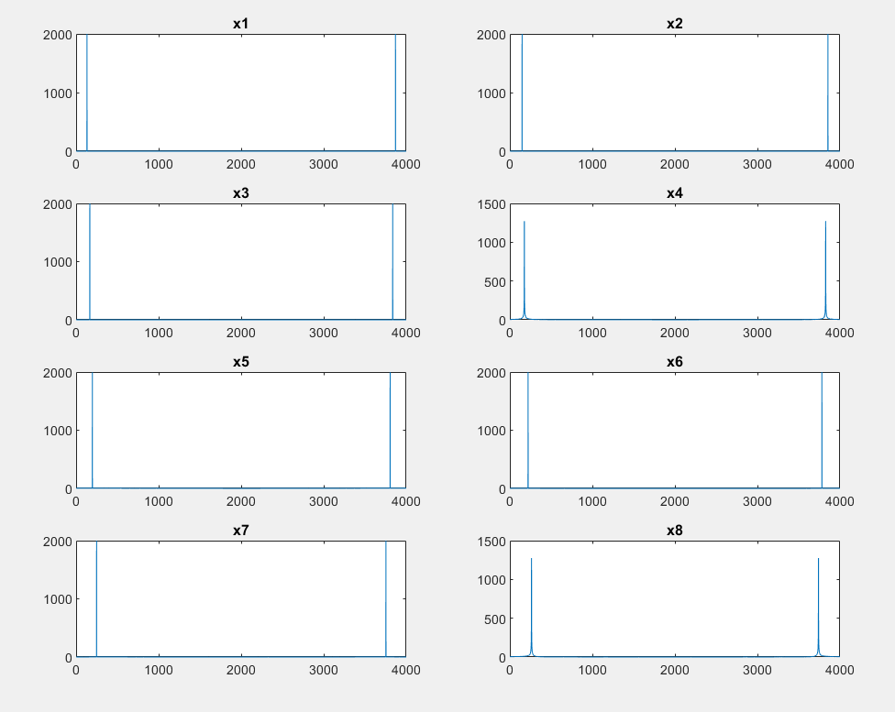title('x8');

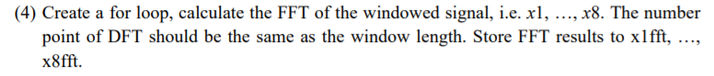

names = {'x1fft' 'x2fft' 'x3fft' 'x3fft' 'x3fft' 'x3fft' 'x3fft' 'x3fft'};

for index = 1 : length(names)

s.(names{index}) = fft(cy1((index-1)*4000+1:index*4000), **4000**);

end

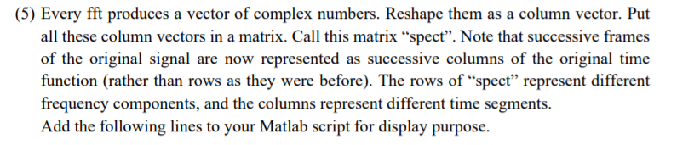

for i=1:8

xfft = cy1((i-1)*4000+1:i*4000);

xfft = fft(xfft, 4000);

spect(:,i) =xfft;

end

window_length = 4000;

spect_mag=20*log10(abs(spect));

plot(spect_mag)

t=(0:window_length:(length(cy1)-window_length))/fs1;

f=(1:window_length)*fs1/window_length;

imagesc(t, f, spect_mag);

axis xy

colormap(jet)

colorbar

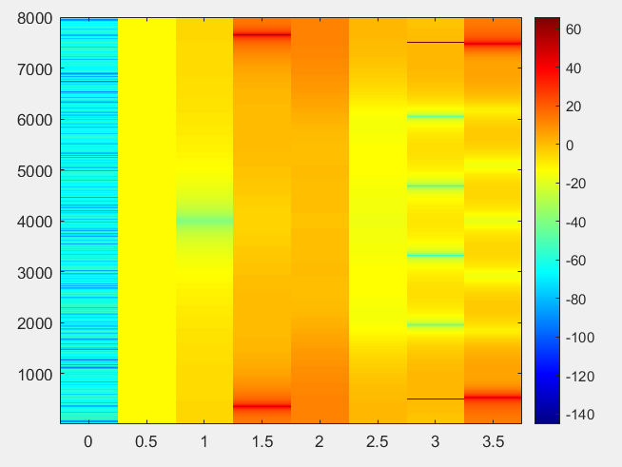

**REPEAT Q3 part (3), (4), (5) for CscaleZ.wav**

[cy2,fs2]=audioread('CScaleZ.wav');

% part (3)

x1 = cy2(1:4000);

x2 = cy2(4001:8000);

x3 = cy2(8001:12000);

x4 = cy2(12001:16000);

x5 = cy2(16001:20000);

x6 = cy2(20001:24000);

x7 = cy2(24001:28000);

x8 = cy2(28001:32000);

subplot(4,2,1),plot(abs(fft(x1)))

title('x1');

subplot(4,2,2),plot(abs(fft(x2)))

title('x2');

subplot(4,2,3),plot(abs(fft(x3)))

title('x3');

subplot(4,2,4),plot(abs(fft(x4)))

title('x4');

subplot(4,2,5),plot(abs(fft(x5)))

title('x5');

subplot(4,2,6),plot(abs(fft(x6)))

title('x6');

subplot(4,2,7),plot(abs(fft(x7)))

title('x7');

subplot(4,2,8),plot(abs(fft(x8)))

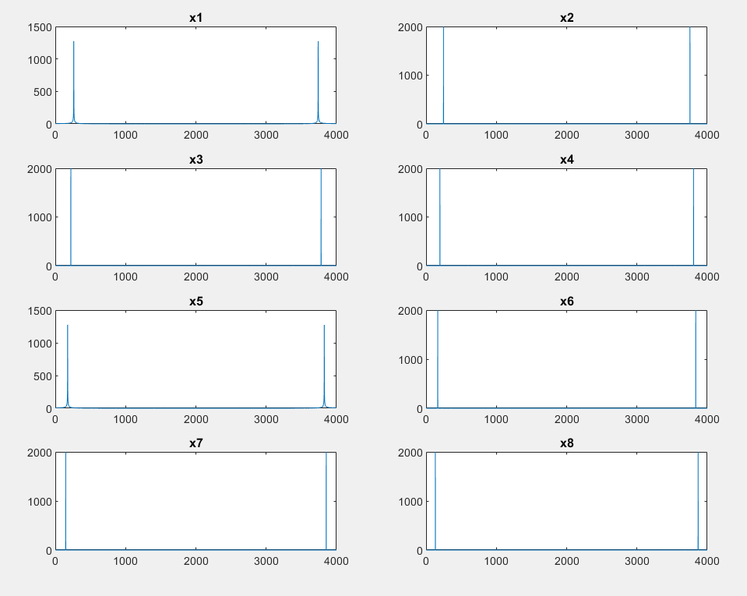title('x8');

% part (4)

names = {'x1fft' 'x2fft' 'x3fft' 'x3fft' 'x3fft' 'x3fft' 'x3fft' 'x3fft'};

for index = 1 : length(names)

s.(names{index}) = fft(cy2((index-1)*4000+1:index*4000), **4000**);

end

% part (5)

for i=1:8

xfft = cy2((i-1)*4000+1:i*4000);

xfft = fft(xfft);

spect(:,i) =xfft;

end

window_length = 4000;

spect_mag=20*log10(abs(spect));

plot(spect_mag)

t=(0:window_length:(length(cy2)-window_length))/fs2;

f=(1:window_length)*fs2/window_length;

imagesc(t, f, spect_mag);

axis xy

colormap(jet)

colorbar

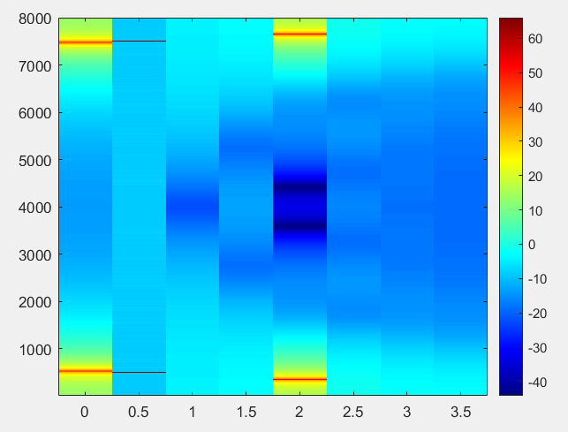

**What are the differences between the spectrogram of CScale and CScaleZ?**

Cscale.wav CscaleZ.wav

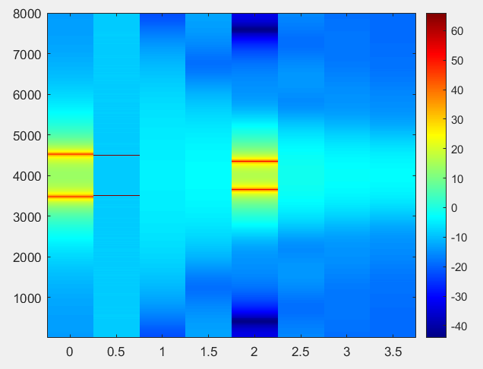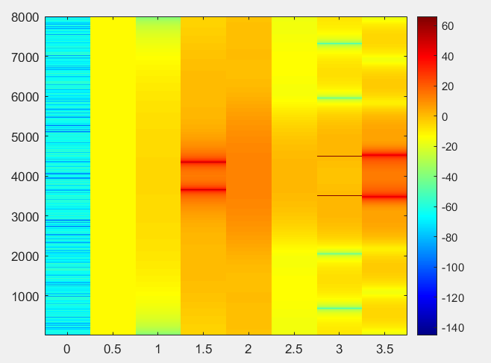After shifting.

Cscale.wav CscaleZ.wav

They both have 8 divisions.

Differences: color scales are different, the direction of sections seems to be opposite to each other, and Cscale.wav has an unusual section at 0 that is not visible in Cscale.wav diagram.

**Compare it with the fft you did in (1).**

There isn’t any visible difference in part (1) solution compared to differences found in part (5) spectrogram solution.

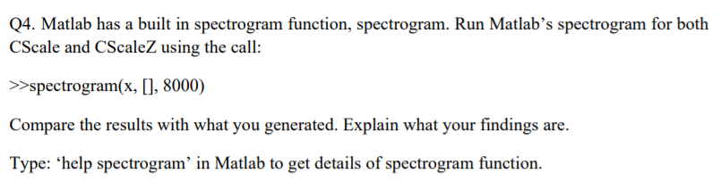

[cy1,fs1]=audioread('CScale.wav');

[cy2,fs2]=audioread('CScaleZ.wav');

subplot(2,1,1),spectrogram(cy1, [], fs1)

subplot(2,1,2),spectrogram(cy2, [], fs2)

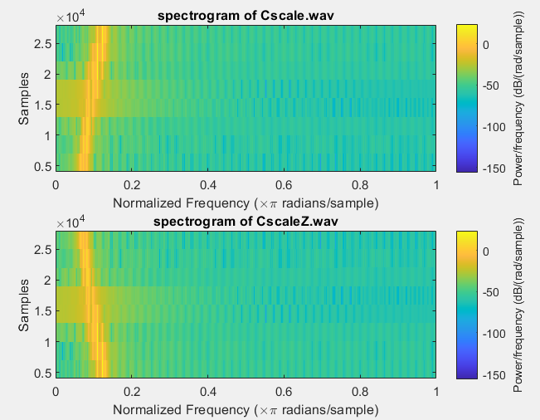

**Observations:** a bright yellow line in spectrogram of Cscale.wav is flipped in spectrogram of CscaleZ.wav. They have opposite slops.

NOTE: the axis is flipped from what has been done in Q3. Therefore, it has been flipped in the plots below.

subplot(2,1,1),spectrogram(cy1, [], fs1, 'yaxis'), title('spectrogram of Cscale.wav');

subplot(2,1,2),spectrogram(cy2, [], fs2, 'yaxis'), title('spectrogram of CscaleZ.wav');

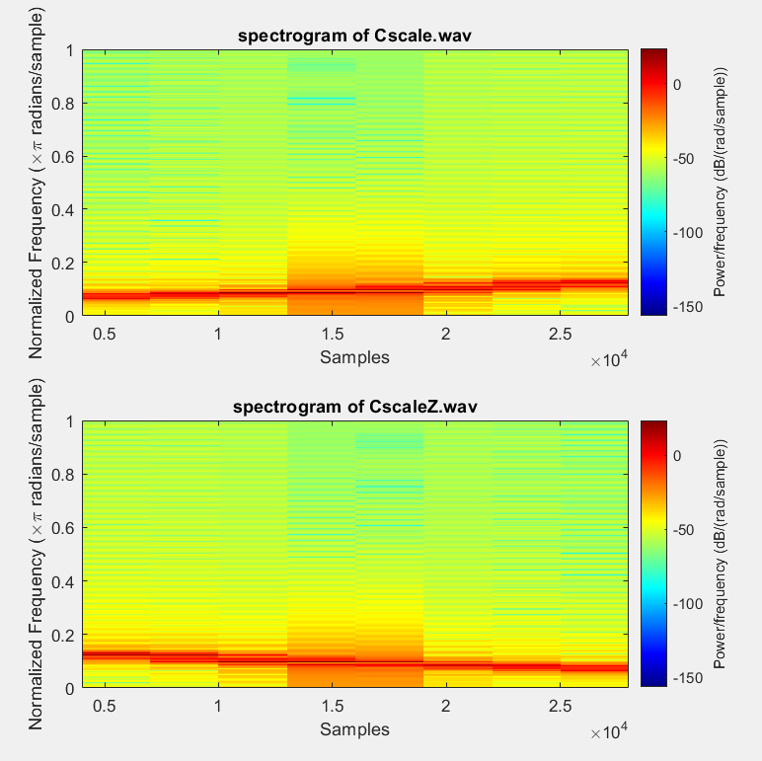

**Observations:** Red line in spectrogram Cscale.wav is increasing its gradient (frequency value increases), but the red line in the spectrogram of CscaleZ.wav is decreasing its gradient (frequency value decreased along the sample axis)

**4. Conclusion: state what you learn from this lab, lab objectives you achieved, and any difficulties you met.**

Learned how to verify the properties of DFT, how to use the convolution to calculate the output of the LTI DT system, and how to use DFT and IDFT to find the output of an LTI DT system.

All the questions were answered using MATLAB and was able to get a better understanding of how to use MATLAB properly in analysing applications using Discrete Fourier Transform.

Q3 was challenging and comparing the results were difficult because the color schemes seems to differ for the comparing sounds.